**SPRING CORE AND MAVEN**

**Exercise 1: Configuring a Basic Spring Application**

**Scenario:**

Your company is developing a web application for managing a library. You need to use the Spring Framework to handle the backend operations.

**CODE:**

**BookRepository.java**

package com.library.repository;  
  
public class BookRepository {  
 public String getBookTitle() {  
 return "Java Programming by John Doe";  
 }  
}

**BookService.java**

package com.library.service;  
  
import com.library.repository.BookRepository;  
  
public class BookService {  
 private BookRepository bookRepository;  
  
 // Setter for Spring XML injection  
 public void setBookRepository(BookRepository bookRepository) {  
 this.bookRepository = bookRepository;  
 }  
  
 public void displayBookTitle() {  
 System.*out*.println("Book Title: " + bookRepository.getBookTitle());  
 }  
}

**MainApp.java**

package com.library;  
  
import com.library.service.BookService;  
import org.springframework.context.ApplicationContext;  
import org.springframework.context.support.ClassPathXmlApplicationContext;  
  
public class MainApp {  
 public static void main(String[] args) {  
 ApplicationContext context = new ClassPathXmlApplicationContext("applicationContext.xml");  
 BookService bookService = (BookService) context.getBean("bookService");  
 bookService.displayBookTitle();  
 }  
}

**OUTPUT:**

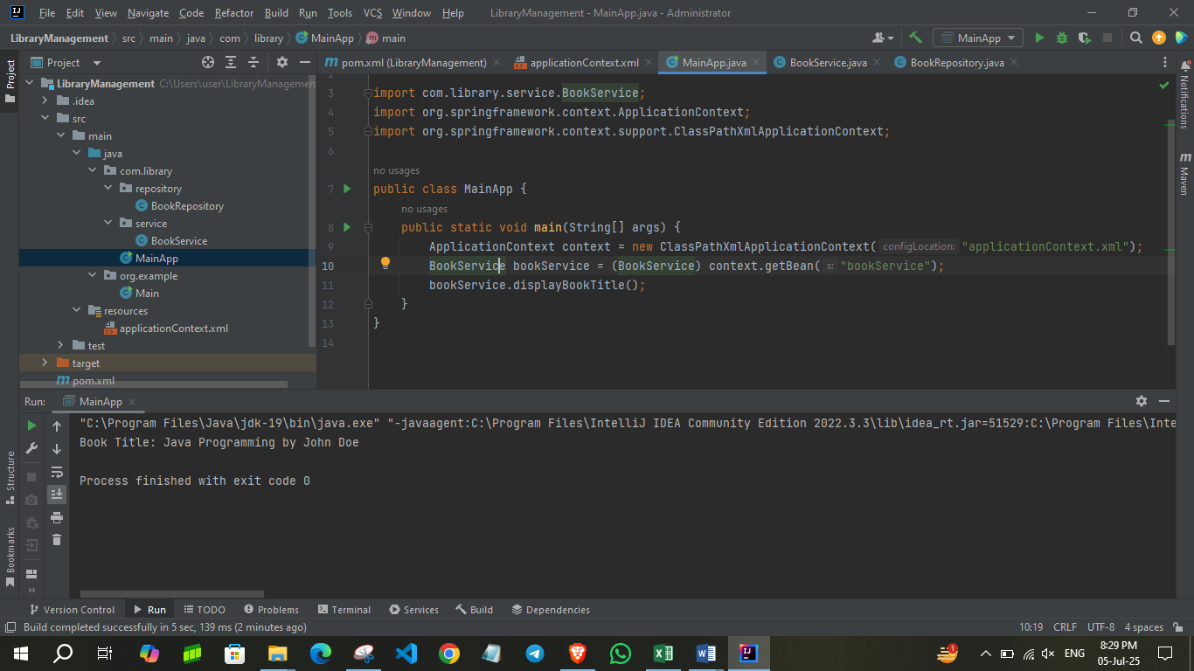

**Exercise 2: Implementing Dependency Injection**

**Scenario:**

In the library management application, you need to manage the dependencies between the BookService and BookRepository classes using Spring's IoC and DI.

**CODE:**

**applicationContent.xml**

<?xml version="1.0" encoding="UTF-8"?>  
<beans xmlns="http://www.springframework.org/schema/beans"  
 xmlns:xsi="http://www.w3.org/2001/XMLSchema-instance"  
 xsi:schemaLocation="  
 http://www.springframework.org/schema/beans  
 http://www.springframework.org/schema/beans/spring-beans.xsd">  
  
 <!-- BookRepository bean -->  
 <bean id="bookRepository" class="com.library.repository.BookRepository" />  
  
 <!-- BookService bean with dependency injected -->  
 <bean id="bookService" class="com.library.service.BookService">  
 <property name="bookRepository" ref="bookRepository" />  
 </bean>  
  
</beans>

**BookRepository.java**

package com.library.repository;  
  
public class BookRepository {  
 public String getBookTitle() {  
 return "Effective Java by Joshua Bloch";  
 }  
}

**BookService.java**

package com.library.service;  
  
import com.library.repository.BookRepository;  
  
public class BookService {  
 private BookRepository bookRepository;  
  
 // Setter injection  
 public void setBookRepository(BookRepository bookRepository) {  
 this.bookRepository = bookRepository;  
 }  
  
 public void displayBookTitle() {  
 System.*out*.println("Book Title: " + bookRepository.getBookTitle());  
 }  
}

**MainApp.java**

package com.library;  
  
import com.library.service.BookService;  
import org.springframework.context.ApplicationContext;  
import org.springframework.context.support.ClassPathXmlApplicationContext;  
  
public class MainApp {  
 public static void main(String[] args) {  
 ApplicationContext context =  
 new ClassPathXmlApplicationContext("applicationContext.xml");  
  
 BookService bookService = context.getBean("bookService", BookService.class);  
 bookService.displayBookTitle(); // Should print: Book Title: Effective Java by Joshua Bloch  
 }  
}

**OUTPUT:**

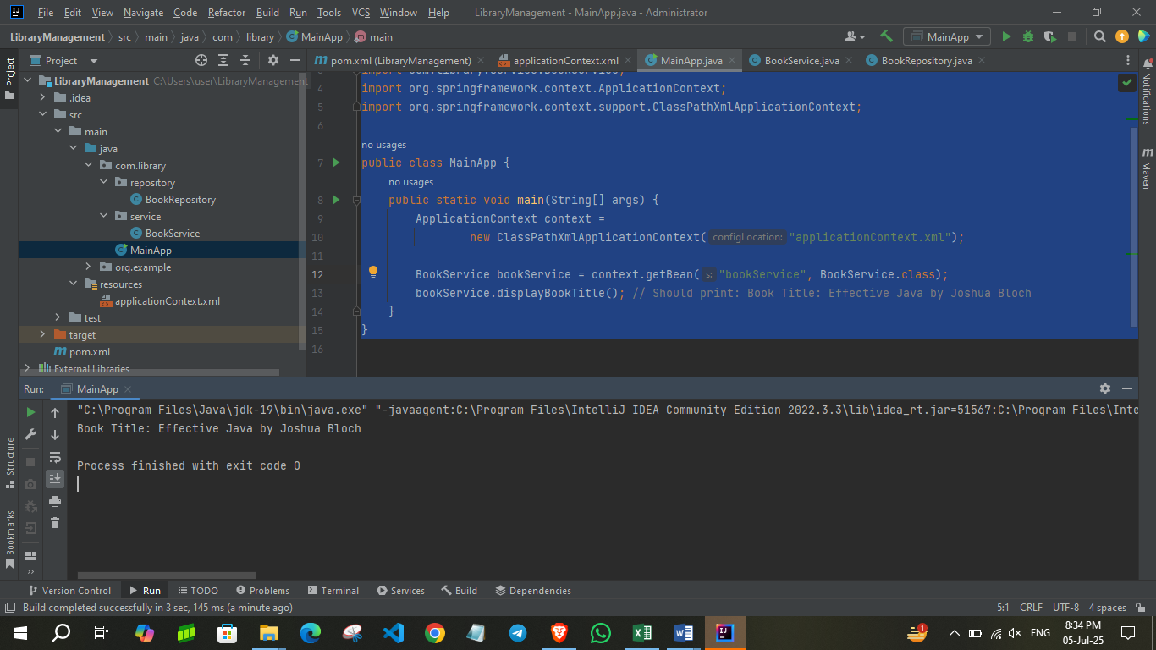

**Exercise 4: Creating and Configuring a Maven Project**

**Scenario:**

You need to set up a new Maven project for the library management application and add Spring dependencies.

**CODE:**

**pom.xml:**

<project xmlns="http://maven.apache.org/POM/4.0.0"  
 xmlns:xsi="http://www.w3.org/2001/XMLSchema-instance"  
 xsi:schemaLocation="http://maven.apache.org/POM/4.0.0  
 https://maven.apache.org/xsd/maven-4.0.0.xsd">  
 <modelVersion>4.0.0</modelVersion>  
  
 <groupId>com.library</groupId>  
 <artifactId>LibraryManagement</artifactId>  
 <version>1.0-SNAPSHOT</version>  
  
 <dependencies>  
 <!-- Spring Core + Bean DI -->  
 <dependency>  
 <groupId>org.springframework</groupId>  
 <artifactId>spring-context</artifactId>  
 <version>5.3.32</version>  
 </dependency>  
  
 <!-- Spring AOP -->  
 <dependency>  
 <groupId>org.springframework</groupId>  
 <artifactId>spring-aop</artifactId>  
 <version>5.3.32</version>  
 </dependency>  
  
 <!-- Spring WebMVC (Optional, useful for future web layer) -->  
 <dependency>  
 <groupId>org.springframework</groupId>  
 <artifactId>spring-webmvc</artifactId>  
 <version>5.3.32</version>  
 </dependency>  
  
 <!-- Optional: JSTL for Web Views (JSP Support) -->  
 <dependency>  
 <groupId>javax.servlet</groupId>  
 <artifactId>jstl</artifactId>  
 <version>1.2</version>  
 </dependency>  
 </dependencies>  
  
 <build>  
 <plugins>  
 <!-- Maven Compiler Plugin -->  
 <plugin>  
 <groupId>org.apache.maven.plugins</groupId>  
 <artifactId>maven-compiler-plugin</artifactId>  
 <version>3.10.1</version>  
 <configuration>  
 <source>1.8</source>  
 <target>1.8</target>  
 </configuration>  
 </plugin>  
 </plugins>  
 </build>  
</project>

**BookRepository.java**

package com.library.repository;  
  
public class BookRepository {  
 public String getBookTitle() {  
 return "Effective Java by Joshua Bloch";  
 }  
}

**BookService.java**

package com.library.service;  
  
import com.library.repository.BookRepository;  
  
public class BookService {  
 private BookRepository bookRepository;  
  
 // Setter injection  
 public void setBookRepository(BookRepository bookRepository) {  
 this.bookRepository = bookRepository;  
 }  
  
 public void displayBookTitle() {  
 System.*out*.println("Book Title: " + bookRepository.getBookTitle());  
 }  
}

**MainApp.java**

package com.library;  
  
import com.library.service.BookService;  
import org.springframework.context.ApplicationContext;  
import org.springframework.context.support.ClassPathXmlApplicationContext;  
  
public class MainApp {  
 public static void main(String[] args) {  
 ApplicationContext context = new ClassPathXmlApplicationContext("applicationContext.xml");  
  
 BookService bookService = context.getBean("bookService", BookService.class);  
 bookService.displayBookTitle(); // ← Output will be printed here  
 }  
}

**OUTPUT:**

